Using the Mathematics Challenge and Enrichment Programs in Your Classroom

Presenters
Dr Kumudini Dharmadasa
Mr. Howard Reeves

Who for?
Mathematics teachers and numeracy leaders. There will be a focus on Years 5 – 8 but teachers of Years 9 – 12 are still welcome to attend. Please note that there is a limit of 35 attendees.

Date
Friday 9th March 2018, 8:30am – 3:30pm

Cost
$75 (MAT Members) / $95 (Non-members) – includes morning tea and lunch

Venue
Professional Learning Institute, 9 Timsbury Road, Glenorchy (Hobart)

Description
Kumudini and Howard are involved as volunteers with the Australian Mathematics Trust which conducts the Australian Mathematics Competition and student enrichment and training programs, leading to Australia’s participation in the International Mathematical Olympiad. In this workshop teachers will:
- be exposed to the mathematical content of the Mathematics Challenge for Young Australians, including the Challenge and Enrichment materials
- consider different strategies to establish an enrichment program in their classes and schools
- develop problem solving strategies and identify the elements of a solution
- discuss the importance of the communication of mathematical ideas

Further information
Administrative questions (e.g. regarding registration) should be directed to Emily Peterson, event organiser, by email: emily.peterson@education.tas.gov.au. Questions regarding the workshop’s content and the MYCA should be directed to Howard Reeves by telephone (0419 389 092) or email: reeves@netspace.net.au.

Register
Via Eventbrite: www.eventbrite.com.au/e/using-the-mathematics-challenge-and-enrichment-programs-in-your-classroom-tickets-42777188723
This link is available at mat.aamt.edu.au.
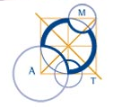 | 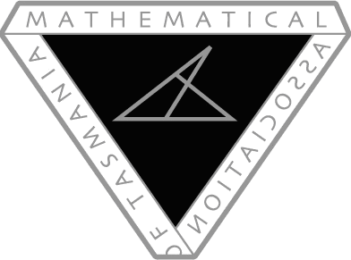
Australian Mathematics Trust | Mathematical Association of Tasmania

